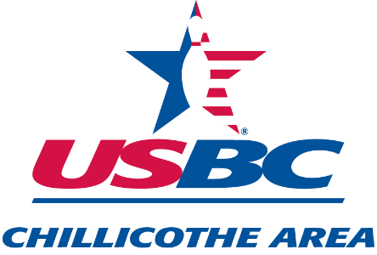
King and Queen of The Lanes
SHAWNEE LANES
1680 NORTH BRIDGE STREET
CHILLICOTHE, OHIO
SUNDAY, MAY 7, 2023
SQUAD TIME 1:00 P.M.
THIS IS A NON-SANCTIONED TOURNAMENT
ENTRY FEE: $30.00
MAKE CHECKS PAYABLE TO CHILLICOTHE AREA USBC
LEAVE ENTRIES AND PAYMENT AT FRONT COUNTER,
ATTENTION: TIM ANDERSON
ENTRIES MUST BE PAID IN FULL WHEN SUBMITTED
Members of Chillicothe Area USBC only
ENTRIES CLOSE MAY 3rd.

NAME_____________________________________________________
PHONE NUMBER_____________________
USBC #______________________
FINAL 2022-2023 AVERAGE: ____________ (Tim will get the final Avg)

RULES FOR THE 2023 KING AND QUEEN OF THE LANES

THIS WILL BE A HANDICAP TOURNAMENT
TOTAL PINS FOR THE 3 GAMES INCLUDING HANDICAP OF 90% BASED ON 230 SCRATCH . MAX HDCP 60 PINS(GAME)
ENTRANTS WILL USE THEIR HIGHEST FINAL LEAGUE AVERAGE AS OF THE END OF THE 2022-2023 FALL SEASON OF AT LEAST 21 GAMES OR MORE.

Bowling format:
3 Games of qualifying. Cut to the top 5 Men and Women.
Top 5 will bowl a bracket format to determine the Champion.

#1
#4
#5
CHAMPION
#2
#3

