Grandparent’s Snakebite Tournament
April 13, 2019 / Check-in 9:00-9:30 AM / Bowling starts at 10 AM
ThunderBowl Lanes – Grove, OK
$20.00
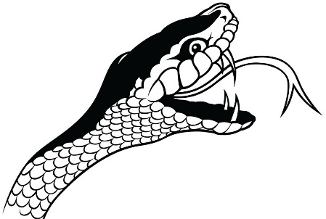
Name____________________________________________________
Phone____________________________________________________
Average__________________________________________________
Number of grandchildren____________________________________
Number of great-grandchildren_______________________________

Tournament Rules
- Open to all grandparents and their life partner
- All 9-count hits and splits will count as a strike.
- A split is defined as when the first ball knocks down the head pin but leaves standing two or more non-adjacent groups of one or more pins.
- Use this year’s current average and if no average is available, women will use 135 average and men will use a 150 average. This tournament is not sanctioned. No USBC card necessary.
- Handicap will be 80% of 210.
- In case of mechanical failure, bowlers may be moved to the next available pair of lanes.
- Total score will consist of 3 games + handicap for each game.
- In the event of a tie, the prize money will be divided equally.
- Payout will be based upon the number of entries at a ratio of 1:4
- Make checks payable to GLAUSBC
- Tournament Director: Carol Andrejak 509-859-3244. Carol bowls the Thursday night league.
Tournament Fees Breakdown
Lineage $10
Prize Fund $8
Admin $2
Total $20

