Online entry instructions:
Step 1: enter the parent or contact name and parent or preferred contact email and phone. Also enter the bowler’s birthdate, gender, and home bowling center. Answer the “not a robot” question. Click “Submit”. (Bowler name will be entered later)
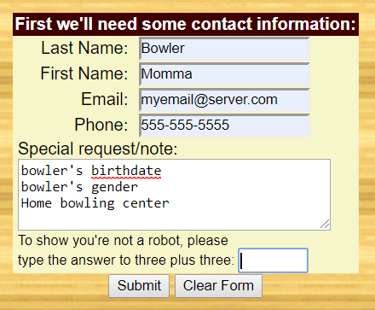

Step 2: Choose the qualifying even for your first bowler. DO NOT choose any finals.
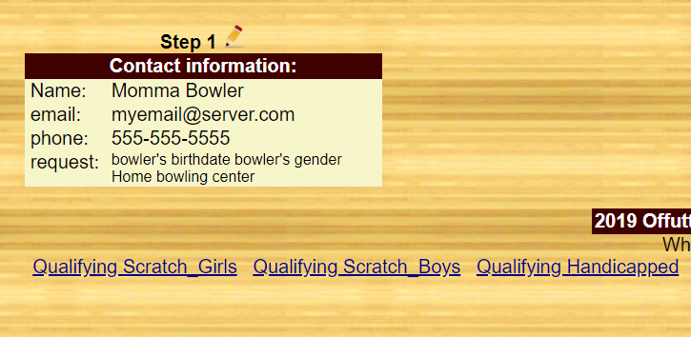

Step 3: Enter bowler’s USBC number, last name, first name, and average. Choose the squad from the drop down. Click “Submit”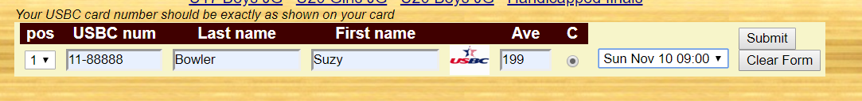

Add additional bowlers for qualifying or select your Junior Gold division. DO NOT select any finals. If you are finished, click “Go” to complete your entry.
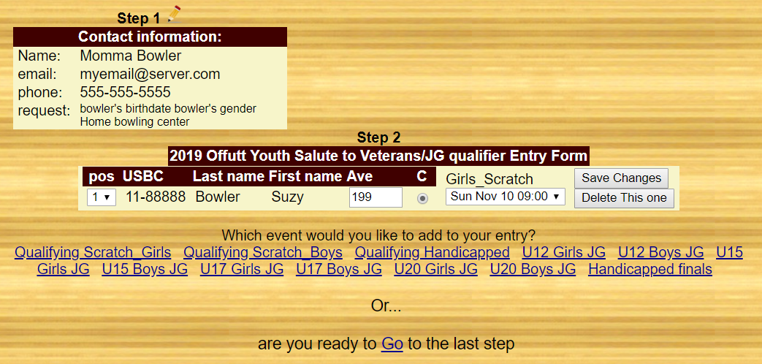

Check over the entry. All events that you’ve entered should be listed. Make sure there is a qualifying event for each bowler. You cannot select a Junior Gold without a qualifying event. Make sure there are no finals in your selection. Do not check the box for paid entries. Online payment is not enabled for this tournament. Click “Submit”. You will receive an email from the tournament director within 48 hours to confirm your entry. Check back often to view the roster to see who’s bowling.