Online entry instructions:
Step 1: enter the parent or contact name and parent or preferred contact email and phone. Also enter the bowler’s birthdate, gender, and home bowling center. Answer the “not a robot” question. Click “Submit”. (Bowler name will be entered later)
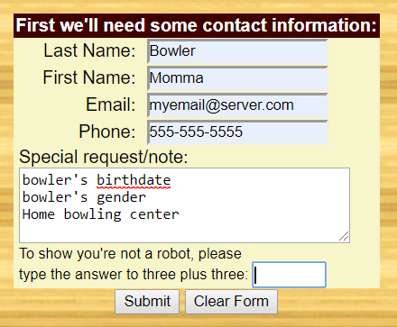

Step 2: Choose the qualifying even for your first bowler. DO NOT choose any finals (if listed). Scratch averages will default to 230. You do not need to enter an average for a scratch bowler.
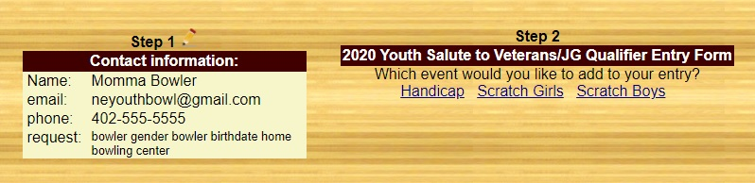

Step 3: Enter bowler’s USBC number, last name, first name, and average. If the bowler has entered a previous event, their name should populate when the USBC number is entered. If the bowler’s name is misspelled, contact the tournament director. We have to go through the webmaster to fix it.
Choose the squad from the drop down. Click “Submit”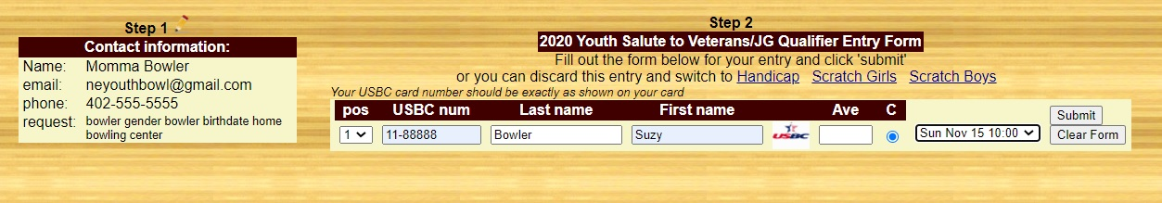

Add additional bowlers. Select the division and fill out the information. If you are finished, click “Go” to complete your entry.
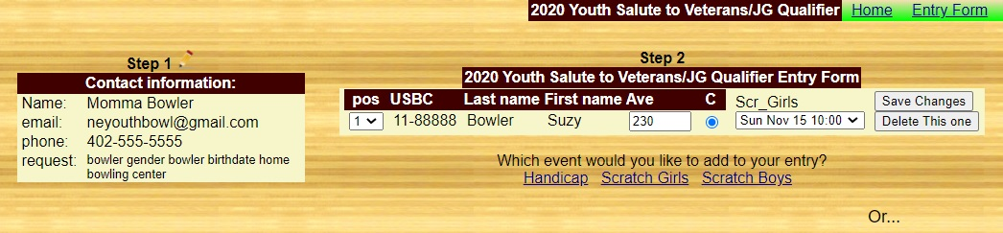

Check over the entry. All events that you’ve entered should be listed. Make sure there is a qualifying event for each bowler. Do not check the box for paid entries. Online payment is not enabled for this tournament. Click “Submit”. You will receive an email from the tournament director within 48 hours to confirm your entry. Check back often to view the roster to see who’s bowling.